CHAPTER 1

INTRODUCTION

* 1. **Background**

I visited my friend’s brother pet shop where I found out that there is no such any proper record keeping system in that shop. I saw that when an old customers come to the shop due to the old paper system it takes almost half hours to find out the old record. So I decided to work on the proper computerized record keeping system.

* 1. **Problem Statement**
* Lack of the proper computerized system on the record keeping
  1. **Objectives:**

To develop a simple website “pet shop management system” using HTML, Javascript, php, CSS and SQL about which we studied during the semester.

1.4 Scopes and Limitations

Scopes of this project includes:

* Gives the detail of the animals and the birds sales.
* Gives the detail about the customer.
* Updating and the deleting of the data is possible .

Limitations of this project include:

* lack of the online feature to the customer.
* Lack of some other features as it works as only the record keeping system.

1.5 Applications

The main application of this project is to give the details of the sales record of the animals and the birds which can be deleted , added and updated.

CHAPTER 2

METHODOLOGY

2.1 Tools and platform

This project will be web-based by using PHP, HTML, JavaScript and CSS and the use of the xampp server host the code was ran.

2.2 Generic model

It consists of a user which is admin can edit update add and delete any details within the system.

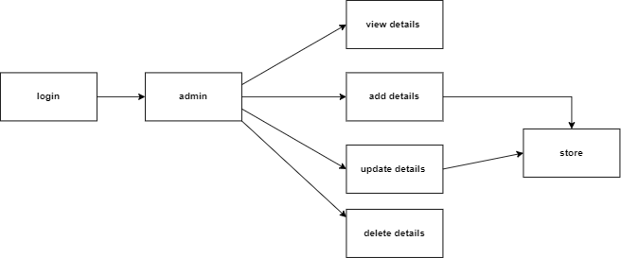

2.3 flowchart

The flowchart of the system is quite simple in which multiple options will come when logged in and can do the operations eaily.

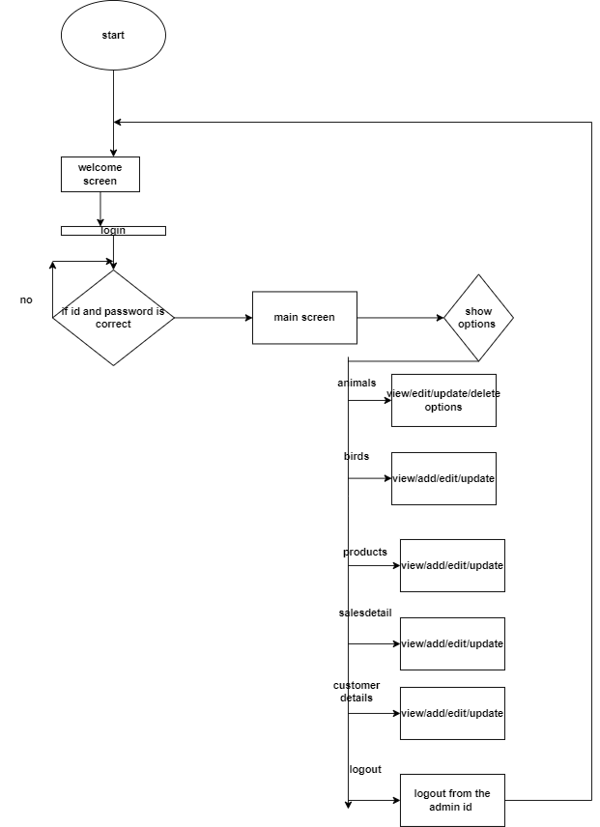

2.4 ER diagram

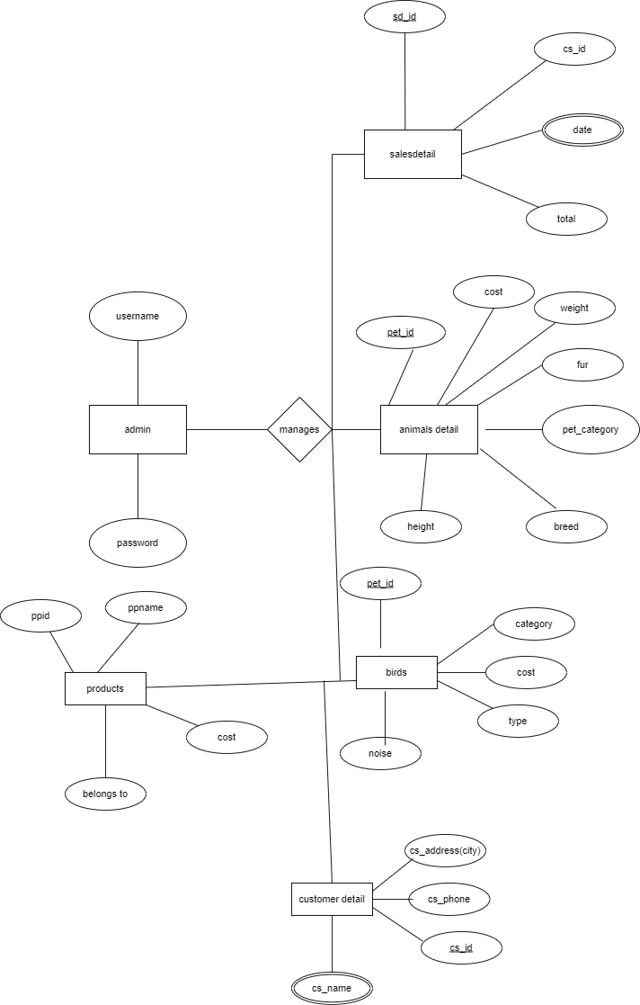

Chapter 3

Results and screenshots

From the above model of the system finally I built a simple pet shop management system with only admin as the user to manage all the data of the pet shop .And below are the some of the results of the my project.

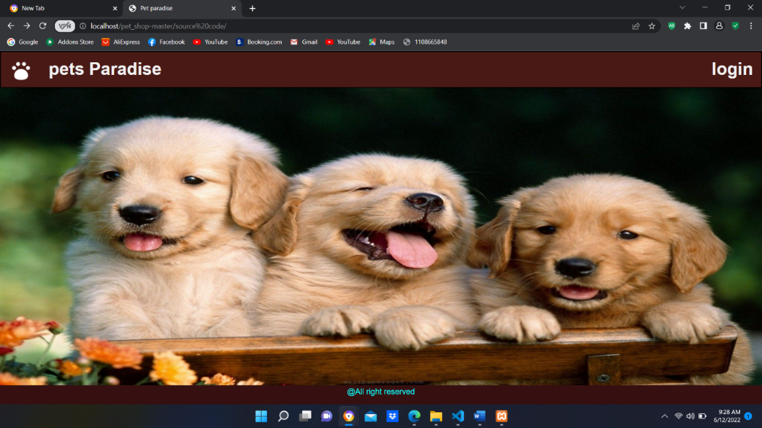

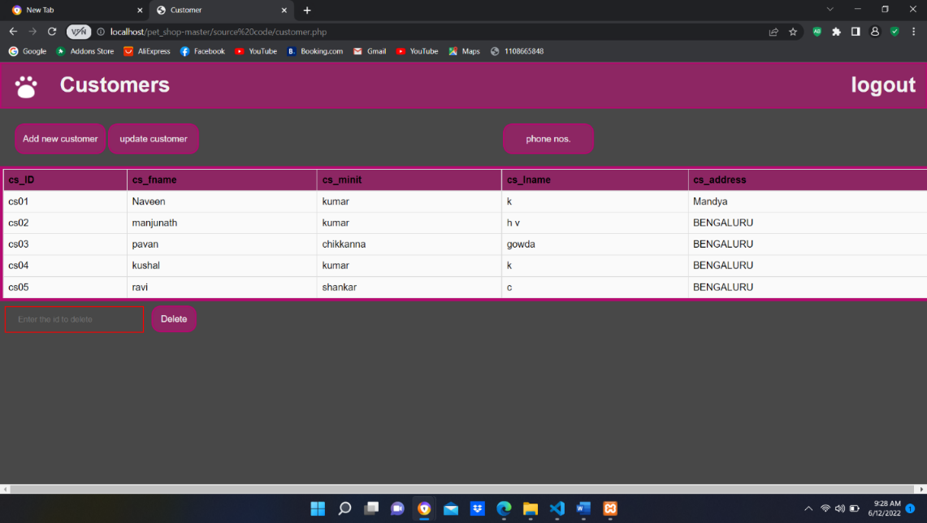

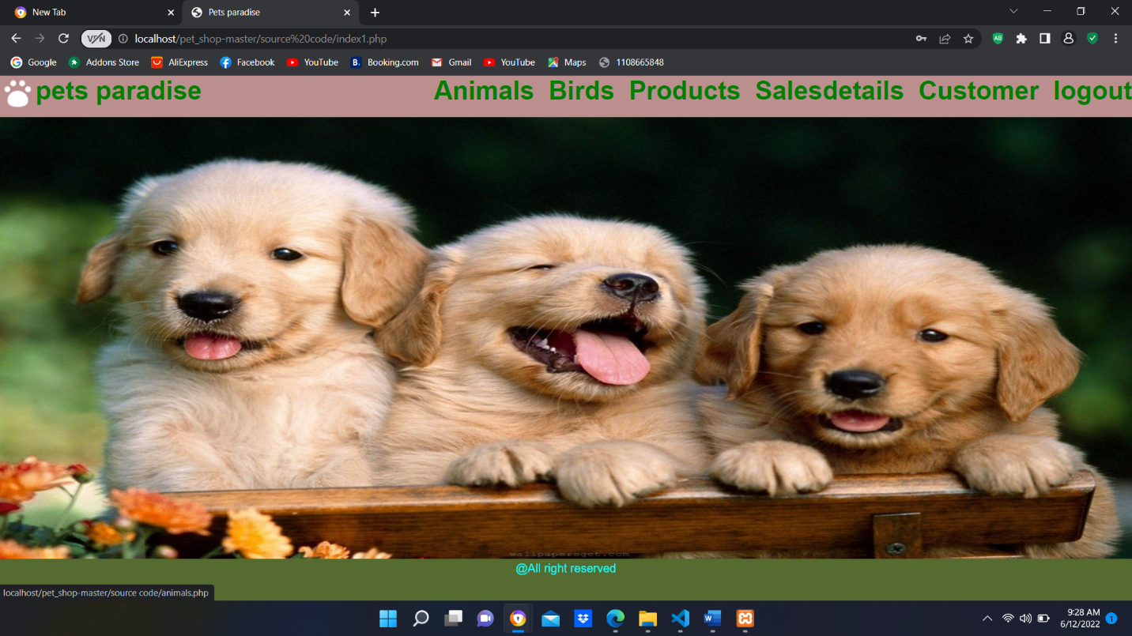

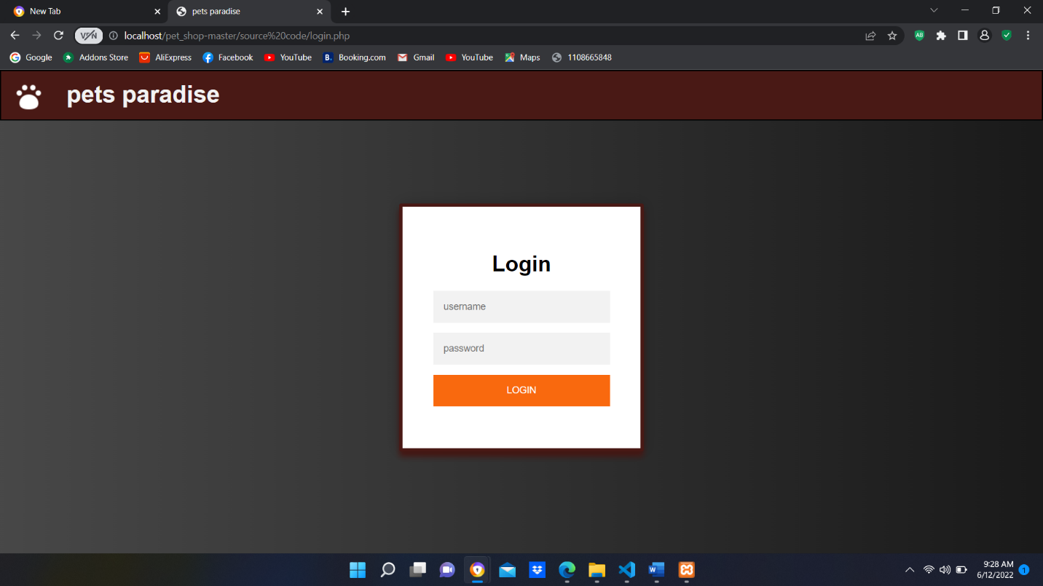

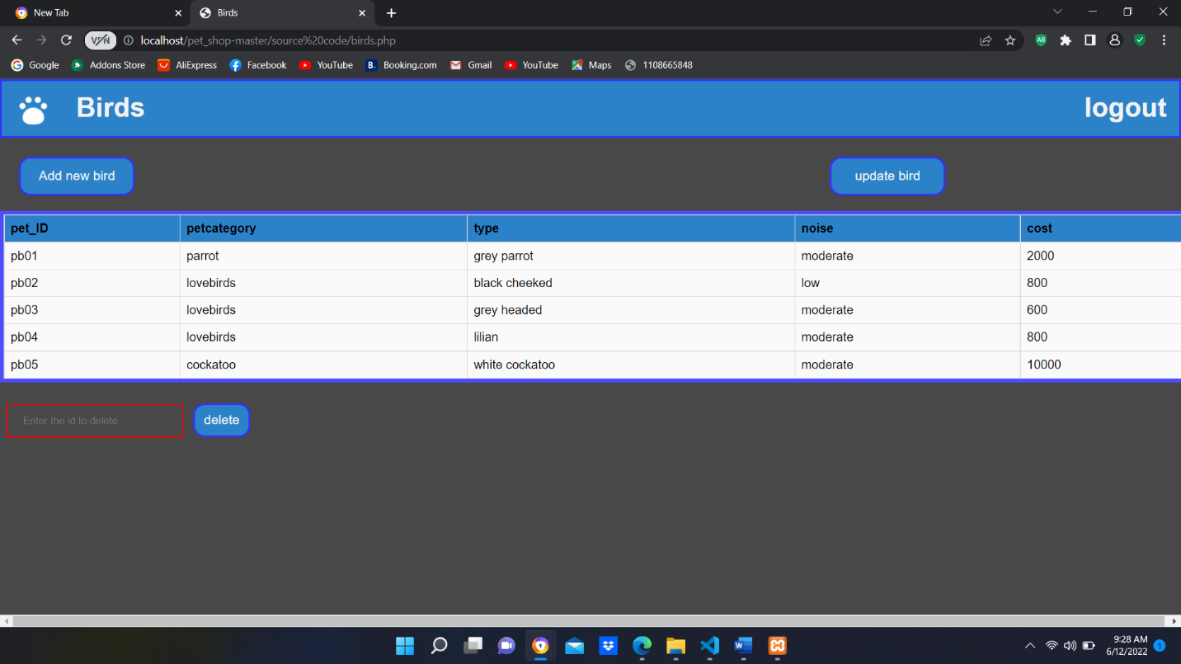

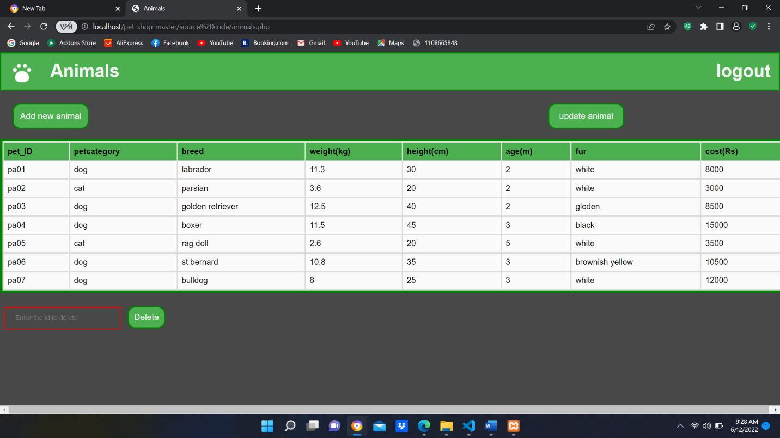

Conclusion

I developed a simple pet shop management system which is used to reduce the paper works. By implementing this website we can use it in the pet shop.